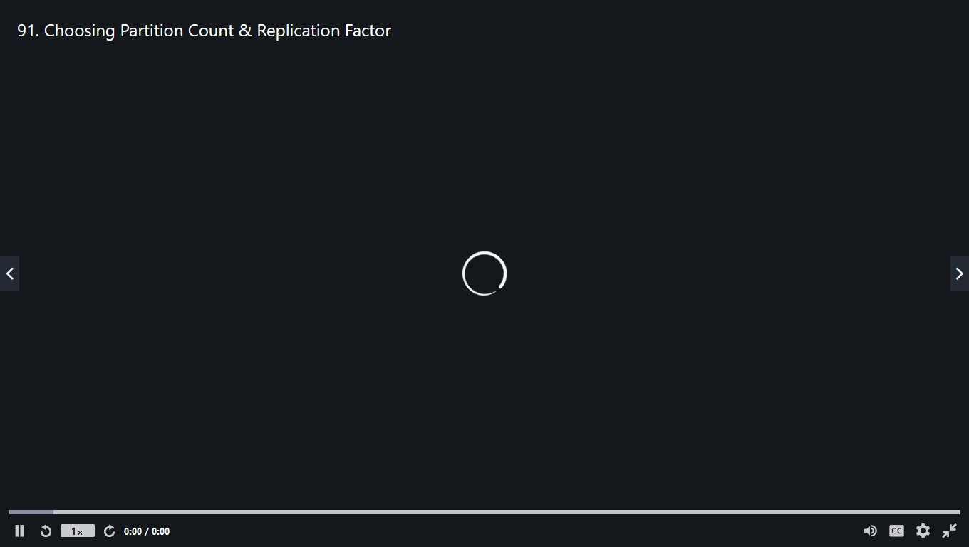

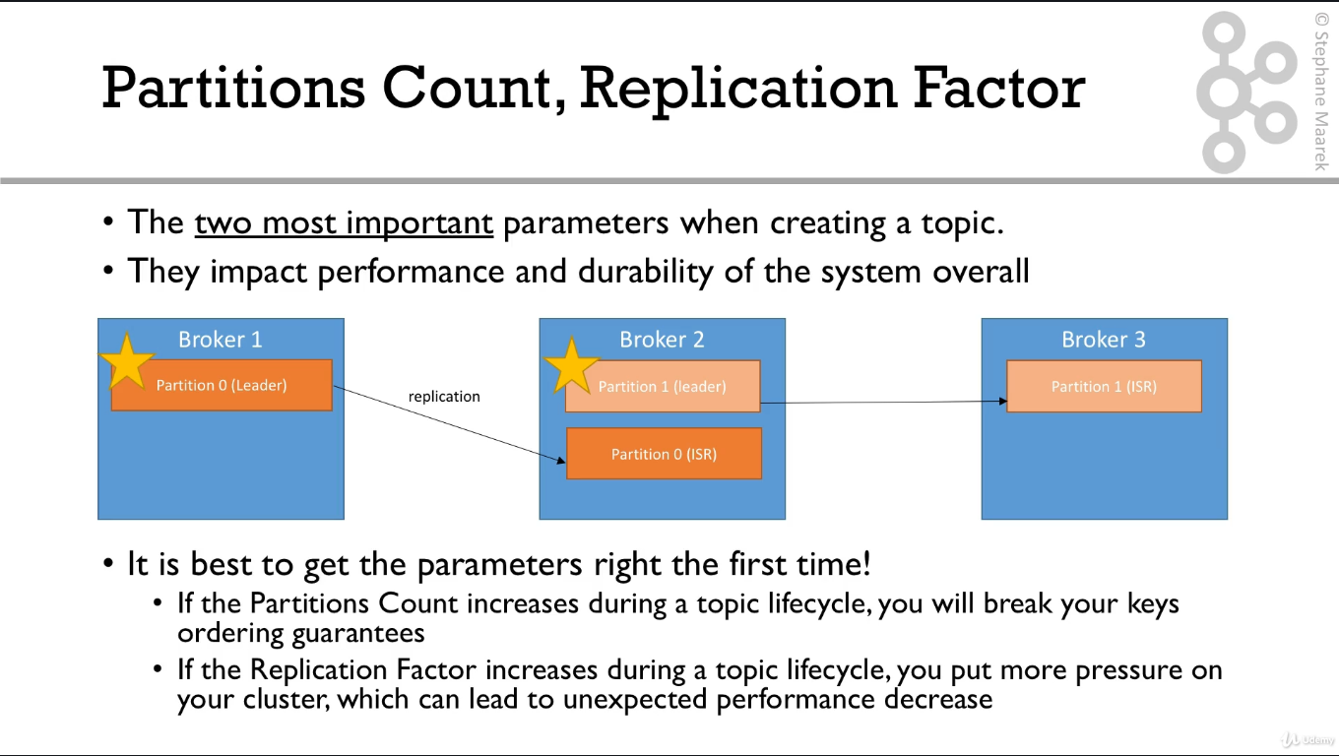

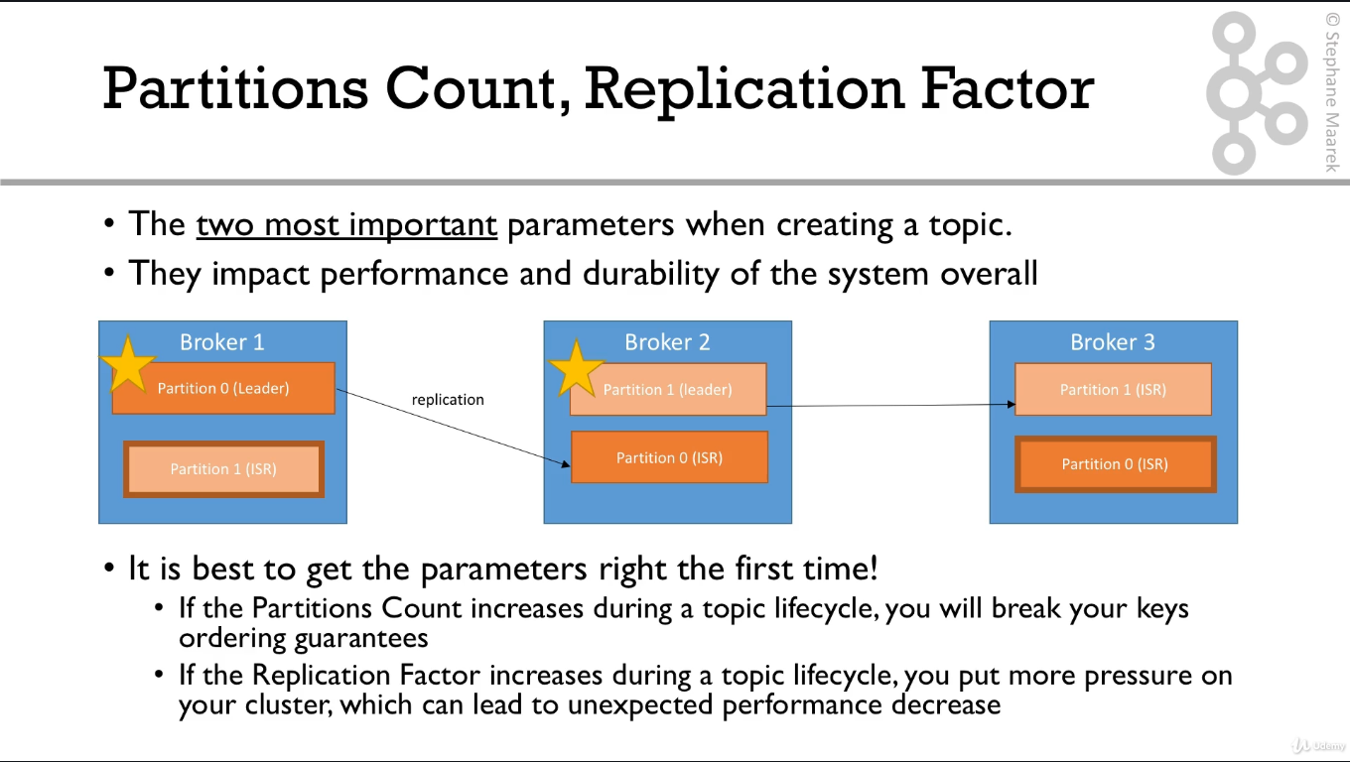

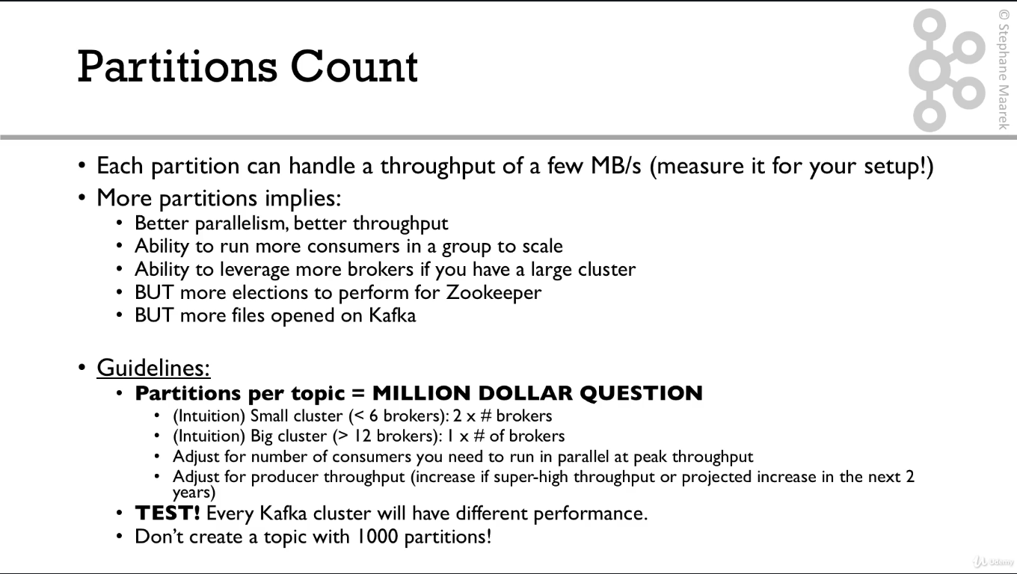

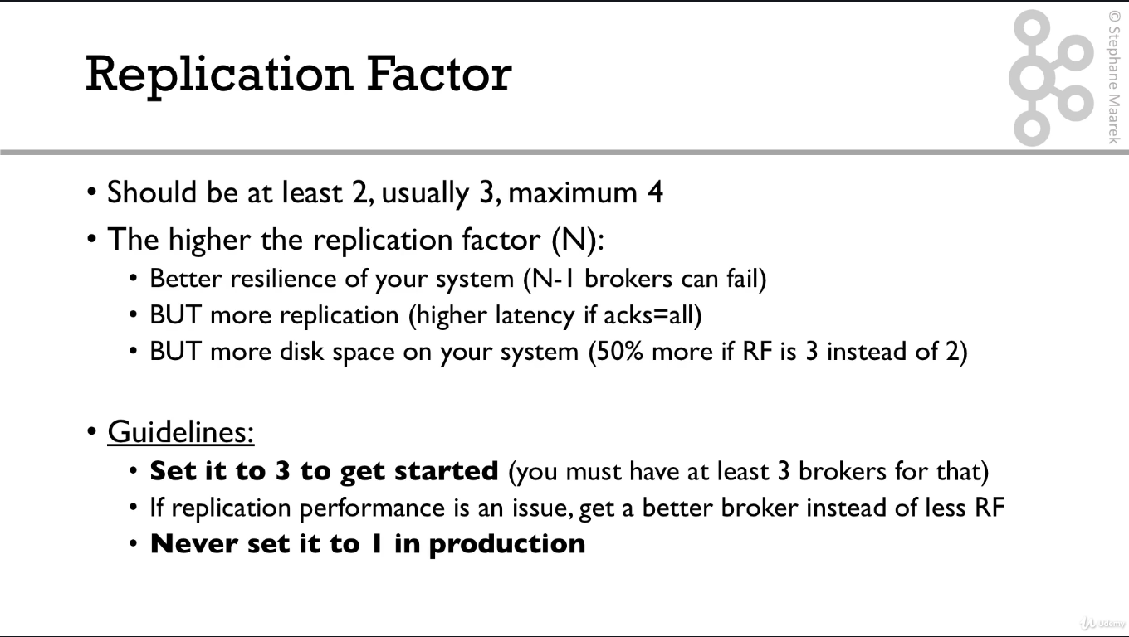

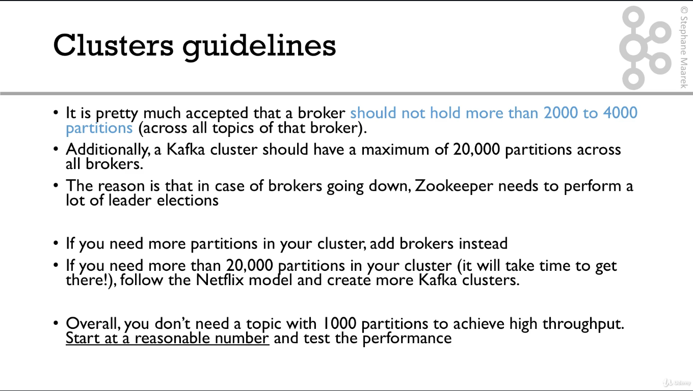

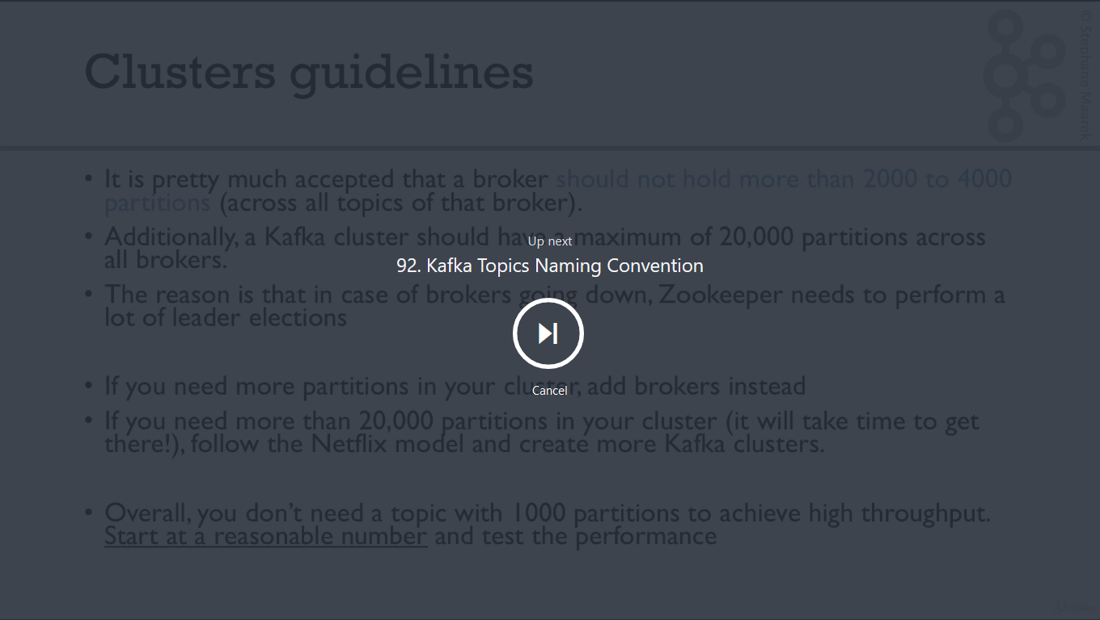

Kafka Topics Naming Convention

**Topic Names**

Topic can have any names you want. It is very important to choose a naming convention in your company to maintain some kind of consistency.

If you need ideas, I recommend reading this blog: <https://medium.com/@criccomini/how-to-paint-a-bike-shed-kafka-topic-naming-conventions-1b7259790073>

